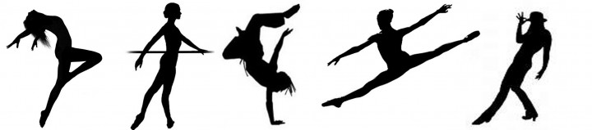
Dance Fitness 9 – 12
Contact
Teacher’s Name: Ms. Dishaw
E-mail address: solenn.dishaw@sd23.bc.ca
I have an office in the counselling centre. Never hesitate to come see me or e-mail me if you have any concerns.

Outline/Objectives
This course is designed for all ability levels and is a great alternative to PE. The objectives of this course are as follows:
-to engage you in daily physical activity
-to improve your overall strength and flexibility
-to develop your knowledge and technique in several dance styles (ballet, jazz, lyrical, contemporary, hip hop)
-to teach you elements of staging and choreography
-to learn choreography, prepare it for performance and perform it for an audience
-apply both knowledge and dance steps and choreography to create original student work
-examine and evaluate other’s choreography
-give you leadership opportunities, especially for those already experienced in dance

Class Rules
-Respect to everyone and everything
-Be prepared
-Be on time
-Bring a good attitude every class and leave the drama at the door!
-Any others you want to add?

Required Supplies
-Stretch/sweat pants or shorts (pants are better for floor work) and a T-shirt or tank top
-water bottle and/or towel (if you sweat A LOT like me)
-yoga mat (you will need your own, please label them and they will be stored in the dance room)
-Dance shoes are NOT required but can be used if you would like to purchase your own. Bare feet will be perfect! For safety reasons socks are not permitted.
-only in the Hip Hop unit will running shoes be required
-PLEASE DO NOT BRING VALUABLES to class or the change room. OKM is not responsible for forgotten, lost or stolen items.
-Hair tie if needed

Tentative Class Structure

-Change into dance strip – 5 minutes
-Attendance will be taken 5 minutes after the bell
-Warm up and stretch – 45 minutes
-Across the floor/combinations – 15 – 20 minutes
-Cool down – 5 minutes
BREAK
-work on choreography – 45 – 60 minutes
-stretching/yoga 15 – 30 minutes
-5 minutes to change out of dance strip

Grading
Your mark will be broken down into 2 parts: Daily Participation and Projects/Assignments
- Daily Participation - 65%. You will be self-evaluating everyday on a 5 point scale. You will be creating this rubric during today’s class.
5 – 90%+
4 – 80 – 90%
3 – 70 – 80%
2 – 60 – 70%
1 – 50 – 60%
0 – under 50%

- Projects/Assignments – 35%. There will be several projects throughout the semester. These might include some of the following:
-creating a CD with an explanation of the mood and/or style of dance that accompanies each song
-creating a final choreography in groups and presenting this to the class
-teach the grade 8 PE classes a short choreography that you developed
-leading the class in part of the warm-up

Attendance
This class is based solely on participation, effort, and attitude. Notes must be provided for excused absences; otherwise, your grade will be affected. If a significant amount of class has been missed, an additional research assignment will be assigned to make-up the classes missed.
Injuries
If you are unable to participate, please make sure you bring a note from a parent or doctor explaining the reasoning.
Field Trips
I’m hoping to take you on one or more field trips this year that relate to dance. I will be getting more information to you as the semester progresses.
If you have any questions or concerns, please do not hesitate to contact me. If you have any suggestions about how to make the year better for you, let me know! I’m very open to suggestions!
Sincerely,
Ms. Dishaw

